What Are Effective Ways to Develop a Healthy New Habit?

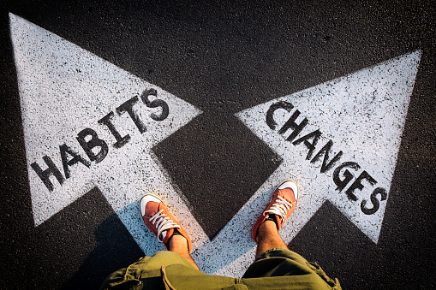

Have you ever wondered why people make plans they cannot stick to? Again, are you always curious to know what makes it difficult for people to change some habits? Well, if you’re interested, this article primarily focuses on educating you more on how to form healthy and new habits. Psychologists argue it takes 21 days for someone to break a habit. But the biggest question is, is that statement true? Well, it’s not. It happens because it may take some people months or even years to build healthy habits. This is the reason people make new resolutions every January, only to quit after a few months.

This happens because the motivation people feel at the beginning of the year is usually short-lived and not sustainable. People don’t know that good habits are not a goal to be achieved tomorrow, but a lifestyle to be lived every day and maintained. Once you start to live a healthy lifestyle, some of these good habits become second nature over time after our brains learn how to enable us to achieve them unconsciously. Below is a list of habits that you can adopt to live a more fulfilling and healthy life.

Create an Exercise Routine

Exercise is a guaranteed way of living a healthy habit. Exercise provides benefits for both your mental and physical health. Scientists tell us that exercise stimulates chemicals like dopamine, serotonin, and others, which are found in the brain. These chemicals work to improve your mood, memory, and learning. When you exercise, your body reduces the chances of you getting some medical conditions like obesity, hypertension, diabetes, heart attack, and others.

Exercising helps you lose excess weight that could otherwise harm you, hence increasing your self-esteem. Doctors encourage people suffering from mental health to exercise regularly, at least 30 minutes daily. This is because exercise stimulates the production of endorphins and serotonin that improve your mood, reduce your stress levels and prevent depression. Sometimes you don’t have to go to the gym or do a vigorous workout. Start with a simple exercise like walking your dog or using stairs instead of a lift, or any other activity that will keep you moving.

Eat a Sustainable Balanced Diet.

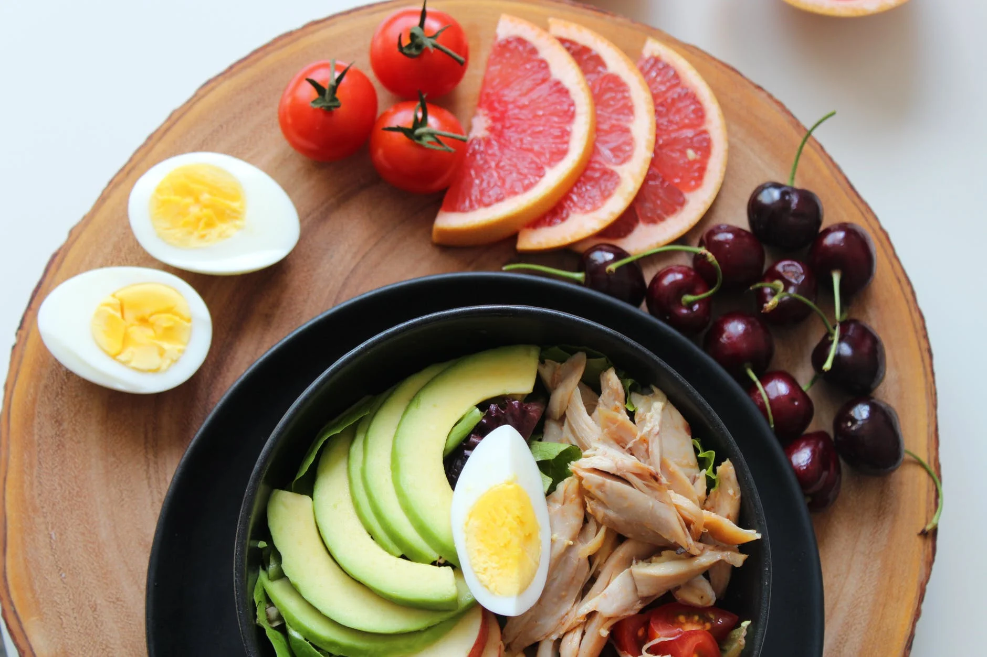

Eating a clean and sustainable diet is one of the best habits you can develop. Choosing clean food is one of the biggest challenges that is facing 21st-century humanity. The rise of technology and social media advertisements has led millions astray into the consumption of unhealthy diets. Because of this, we have increasing cases of lifestyle diseases like hypertension and diabetes, and obesity as well. You don’t have to be a victim of this. You can create your healthy lifestyle by
- Quit sugar, caffeine, and wheat flour products like pasta and bread. They all spike up your blood glucose levels, adding to unnecessary weight. Sugar also triggers skin inflammation, and tooth cavities and impairs nerve functioning.
- Advocate for green leafy vegetables and citrus fruits. They contain lots of important vitamins and antioxidants to help boost your immune system, protecting you from diseases.
- Choose to eat seafood, poultry, and eggs for lean proteins.
- Reduce salt intake as it increases your risk of retaining excessive fluids, which can give you hypertension. When buying food like soy sauce, soups, food additives, sausages, etc, check for salt content, as most of these products contain high amounts of hidden salt.
- Use healthy cooking oils like virgin olive oil and avocado oil as they have no unhealthy saturated fats.

Manage Stress Accordingly

Stress can do so much harm to our bodies, knowingly or unknowingly. When you are under stress, your body releases cortisol, a hormone that controls flight or fight mode. Cortisol also causes weight gain, lowers your focus and concentration, and also weakens your immunity. Finding the right way to relieve stress can help you avoid mental health and other health-related issues early. There are proven ways to manage stress and including
- Practice meditation and visualization behaviors.
- Learn yoga and breathing exercises.
- Create a culture of writing things that stresses you out
- Avoid being around people or things that give you negative energy.
- Read a book or listen to relaxing music to calm your brain down.
- Go for a walk, as it will help you focus on other things.

Get Quality Sleep Every Day.

Sleep is the very key to our survival. There is nothing we can accomplish as human beings without adequate sleep. Scientists recommend we get at least 6-7 houses of sleep every day to function properly. We live in a very busy society that does not value sleep. People sleep late and wake up early to go to work and catch up with friends on social media. Being updated on the new trends is not a bad idea, but you should not use your bedtime hours to do these activities. They may sound good, yes, but what you don’t know is that they deny you an opportunity to get proper rest to remain productive the following day.

According to a study published by the American Journal of Managed Care in 2020, it showed that 50-70 million adults in the USA suffer from a sleep disorder, while 25 million adults have obstructive sleep apnea. If these numbers are only for Americans, what does this mean? It means that there are millions of people who don’t sleep well globally. Sleep is as important as exercise and eating healthy. When we sleep, the body repairs its cells and takes us back to functioning normally. This explains why quality sleep is linked to mood elevation, productivity, excellent memory, concentration, and general happiness.

Develop Deep and Genuine Friendships.

We are social beings and this means that we can do very well in life if we don’t connect with our friends and families. Sometimes it’s easier to think that healthy living involves only our physical bodies, but that’s not true. Emotional, spiritual, and psychological health is equally important. In a society where most people seem to chase dreams while forgetting the importance of forming friendships, it’s good to have people you can connect with. When I say friendships, I mean deep, genuine, working, and supportive relationships. Unlike other animals, as human beings, we are very complex and depend on these friendships to survive in many aspects of life. Good friendships:
- Help us fight the loneliness that leads many people to a life of isolation and depression.
- Explore our full potential and be healthy.
- Encourage us to change or avoid some toxic behaviors
- Help people cope with loss, grief, trauma, job loss, and divorce.
- Gives us a sense of belonging.

Appreciate Yourself More

The art of self-appreciation is not so common, but learning it is worth it. Sometimes we are so preoccupied with things to a point where we forget we matter. Many people are used to receiving kind words and appreciation from others and it is a good thing. However, you should be the first person to love and be kind to yourself first before your friends and family. When you master this habit, when people say negative things about you will never get into your head. There are many ways of reminding yourself that you are worth it. Therefore,
- Reward yourself with gifts, vacations, and holidays.
- Remember the good things you have so far accomplished and be grateful.
- Stop judging yourself too harshly when you fail or things don’t go as you expected.
- Stop doing things that remind you of your past mistakes.
- Accept and appreciate your body image.
- Be your authentic self.

The Bottom Line

Creating healthy new habits takes time, effort, and a lot of patience. You cannot expect to start a good habit today and to see the results tomorrow. Temptations to quit will always be there to drag you down, but constantly remind yourself that you’re not alone, others have been there too. You can replace your evening glass of wine with a protein smoothie, and your two hours of watching your favorite TV show with a thirty minutes walk daily. It’s hard to start too many new habits at once, as this will make you feel exhausted. Instead, choose to focus on one habit at a time, and once it has become a part of your daily routine, you can now introduce a new healthy habit. Creating healthy habits requires a friendly environment, too. What do I mean by this? There is no way you can expect to be healthy while hanging out with people who enjoy burgers and fried chicken. As you strive to change, your environment also needs to change and adapt to these changes.

